AMK-RESEARCH LAB TRAINING & RESEARCH DEVELOPMENT FRAMEWORK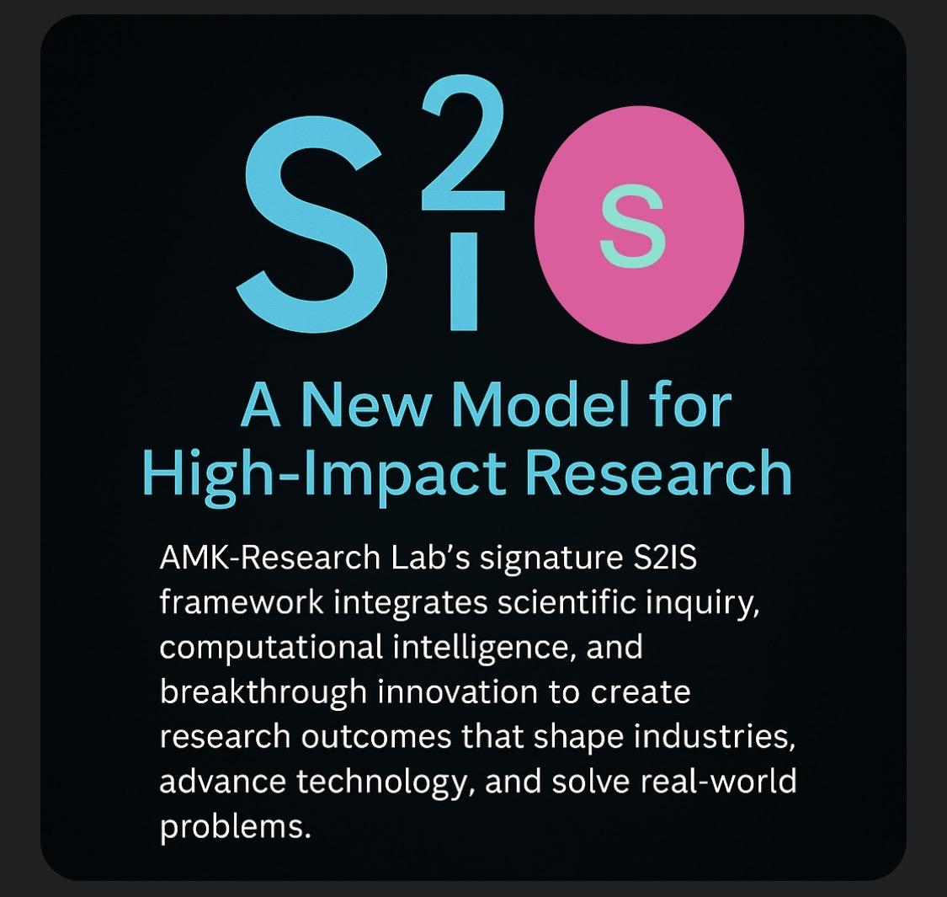
Science → Intelligence → Innovation (S²I Approach)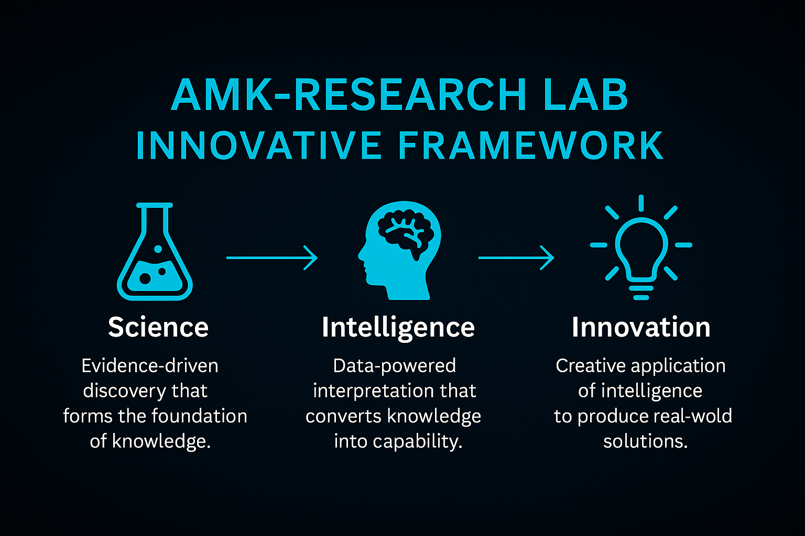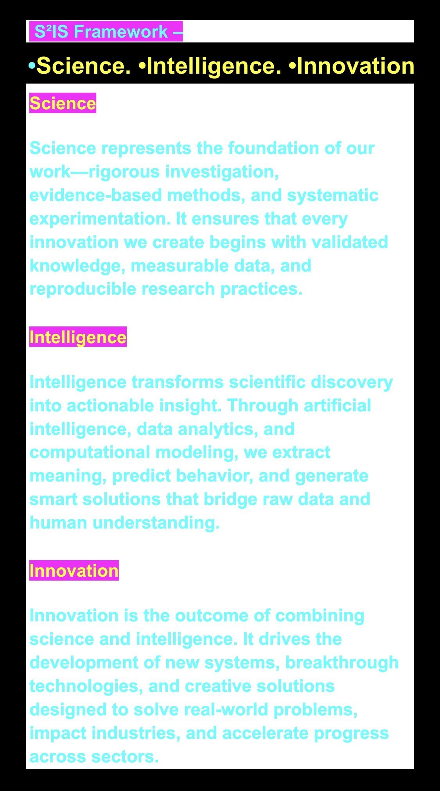
A uniquely engineered multi-tier learning and research system that prepares learners from high school to industry to master cyber-physical systems, AI-driven security, aerospace intelligence, and frontier research methodologies.

A. Multi-Level Training Pathways
AMK-RESEARCH LAB tailors its curriculum so that each learner receives age-appropriate, intellectually progressive, and industry-aligned training.

1. High School Students (Foundation Track)
- Introduces fundamental concepts in AI, cybersecurity, and scientific reasoning.
- Builds curiosity-driven learning through simulations, mini-projects, and supervised experimentation.
- Focuses on digital literacy, computational thinking, research awareness, and responsible tech usage.

2. College Students (Exploratory Track)
- Reinforces hands-on skills in programming, IoT devices, robotics, and basic threat modeling.
- Develops technical writing skills, research reading habits, and early scientific inquiry.
- Engages students in guided capstone-style projects with structured mentorship.

3. Undergraduate Students (Applied Research Track)
- Introduces applied machine learning, cloud computing, IoT security, UAV operations, and CPS engineering.
- Integrates academic rigor with practical labs, datasets, and real-world industry case studies.
- Trains students in academic publishing fundamentals and ethical AI practices.

4. Graduate Students (Advanced Research & Innovation Track)
- Provides in-depth training on AI–CPS integration, IIoT architectures, adversarial AI, and cyber-defense engineering.
- Conducts high-level seminars on research design, algorithm development, and scientific communication.
- Prepares students for journal publications, conference papers, and advanced computational modeling.

5. Industry Professionals (Executive & Specialist Track)
- Focuses on strategic cybersecurity management, digital risk governance, and advanced analytical skills.
- Emphasizes enterprise architectures, regulatory alignment, AI governance, and systems resilience.
- Tailored workshops include threat detection pipelines, SOC modernization, UAV/CPS risk, and AI operationalization.

B. Program Learning Outcomes (PLOs)
AMK-RESEARCH LAB ensures all learners achieve intellectual mastery, technical depth, and research competence.

General Learning Outcomes (GLOs)
Learners will be able to:
- Demonstrate foundational-to-advanced understanding of AI, IoT, CPS, cybersecurity, and digital ecosystems.
- Analyze complex cyber-physical challenges using data-driven, ethical, and scientific principles.
- Apply research methodologies to investigate real-world problems.
- Communicate findings through technical reports, presentations, and scientific papers.
- Develop innovative solutions aligned with global technology standards.

Specific Learning Outcomes (SLOs)
Upon completion, students will:
- Construct AI models tailored to CPS and aviation systems.
- Implement cybersecurity mitigation strategies in multi-layer architectures.
- Design data acquisition pipelines, custom sentiment dictionaries, and algorithmic workflows.
- Execute end-to-end research projects using academic standards and publication protocols.
- Critically analyze geopolitical, aviation, and cybersecurity intersections, including BRICS dynamics.

C. Methodology / Approach (S²I Instructional Model)
AMK-RESEARCH LAB uses a dual-pedagogical and research-driven approach:

1. Science (Knowledge Building)
- Core theory, conceptual grounding, mathematical foundations.
- Evidence-based instruction supported by current academic literature.

2. Intelligence (Applied Problem-Solving)
- Hands-on labs, datasets, simulations, UAV missions, threat modeling.
- Integration of AI, IoT, IIoT, AIIoT, cybersecurity architecture, and aerospace systems.

3. Innovation (Creation & Research Output)
- Students develop publishable research, computational models, and engineering prototypes.
- Advanced tools include Python, R, Linux, simulators, AI frameworks, and CPS datasets.

D. Curriculum Structure: Specialized & Technical Domains

Three Specialized Domains

(i) AI, IoT, AIIoT, IIoT, Aerospace & UAV Cyber-Physical Systems
- AI foundations (ML, DL, Transformers)
- IoT/IIoT architectures & protocols
- UAV operations & autonomous flight
- CPS resilience engineering and AI robotics

(ii) Cybersecurity Management Systems & Mitigation Strategies
- Policy frameworks (NIST, ISO, GDPR, POPIA, HIPAA)
- Incident response, SOC integration, SIEM pipelines
- Cyber risk analysis and enterprise governance

(iii) Cybersecurity Defense Architecture & AI as a Vector of Adversity
- Adversarial ML
- Red-team/blue-team CPS scenarios
- Zero-trust systems, secure by design, digital forensics

Two Technical Domains

(iv) Data Acquisition & Algorithm Engineering
- Dataset selection, preprocessing, and augmentation
- End-to-end ML pipeline design
- Statistical modeling and computational analysis

(v) Custom Dictionary Design for Sentiment Research
- Building domain-specific lexicons for aviation, cybersecurity, geopolitics
- Creating multilingual token sets
- Integration into transformers and sentiment pipelines

Extended Topics

Aviation Topics
- Aviation safety analytics, risk perception models
- Crew/passenger sentiment research
- AI-enabled GPS spoofing/jamming detection for aircraft and UAVs
- Digital aviation ecosystems and smart airports

UAVs in the AI Era
- UAV autonomy
- Swarm intelligence
- UAV cybersecurity & mission simulations

BRICS & Geopolitical Research
- Cybersecurity governance across BRICS
- Comparative AI policy analysis
- Digital sovereignty, cyber diplomacy, and emerging tech alliances

E. Steps to Research Publications (AMK-Research Pipeline)

Step 1: Topic Identification

a. Topic Selection
Aligned with industry demands, global trends, and research gaps.

b. Abstract / Overview
Concise summary (150–250 words).

c. Graphical Abstract
A visual snapshot of the research contribution.

d. Keywords
For indexing, searchability, and digital libraries.

Step 2: Introduction & Research Foundations
a. Background/context
b. Problem statement
c. Research questions or hypothesis
d. Contributions to knowledge
e. Gap analysis
f. Paper organization structure

Step 3: Literature Review (Last 5 Years)
a. CRAAP evaluation (Currency, Relevance, Authority, Accuracy, Purpose)
b. Citation mapping
c. Reference listing
d. APA 7th in-text citations

Step 4: Methodology (Materials & Methods)

4.1 Approaches
- Quantitative
- Qualitative
- Mixed methods
Includes:
(i) Peer-reviewed source selection criteria
(ii) Exclusion justification
(iii) Visual representations (tables, charts, diagrams)

4.2 Materials and Tools
a. Python, R, Jupyter Notebooks, RStudio
b. Data acquisition → preprocessing → partition → training
c. Bias removal, fine-tuning, robustness testing
d. Evaluation metrics (Precision, Recall, F1, ROC-AUC, etc.)
e. Pseudocode/Algorithm design
f. Methodological limitations

Step 5: Data Analysis & Results
a. Interpretation and narrative building
b. Figures, tables, charts, statistical summaries
c. Major contributions
d. Secondary findings

Step 6: Discussion
a. Verification of expected outcomes
b. Alignment with hypothesis
c. Lessons for future researchers
d. Impact stakeholders (government, military, industry, academia)
e. Supporting tables/figures included

Step 7: Conclusion & Future Directions
a. Restate problem/hypothesis
b. Contributions & recommendations
c. Summative conclusion (250–500 words)

Step 8: References / Bibliography
- All scholarly works cited
- APA 7th or journal-specific formatting

Appendices / Supplementary Material
- Additional data, source code snippets, extended diagrams, raw results.

