AMK Research Lab
Science • Intelligence • Innovation

International Benchmark Lecture Notes
Artificial Intelligence Engineering Certification Program

Prepared as a teaching handbook aligned to recognized international AI, software engineering, deployment, and governance practices.

Program duration | Recommended 40 hours
Delivery mode | Lecture + lab + workshop + capstone
Primary stack | Python, Jupyter, NumPy, pandas, scikit-learn, TensorFlow, PyTorch
Benchmark lenses | ACM/AAAI/IEEE curricular guidance, NIST AI RMF, ISO/IEC 42001 and 23894, OECD, and UNESCO AI principles

Version: April 2026

1. Program overview and benchmark logic
These lecture notes turn the proposed certification into an instructor-ready teaching pack. The notes are benchmarked against internationally recognized guidance for AI education, AI risk management, software engineering practice, and responsible deployment. The goal is not to imitate a single vendor course, but to combine foundational AI engineering, applied coding, deployment discipline, and governance into one coherent curriculum.
A strong AI engineering certification should do four things well: teach the technical foundations, build implementation fluency, expose learners to real deployment constraints, and train them to manage ethics, risk, and accountability. That is the organizing logic used in this handbook.
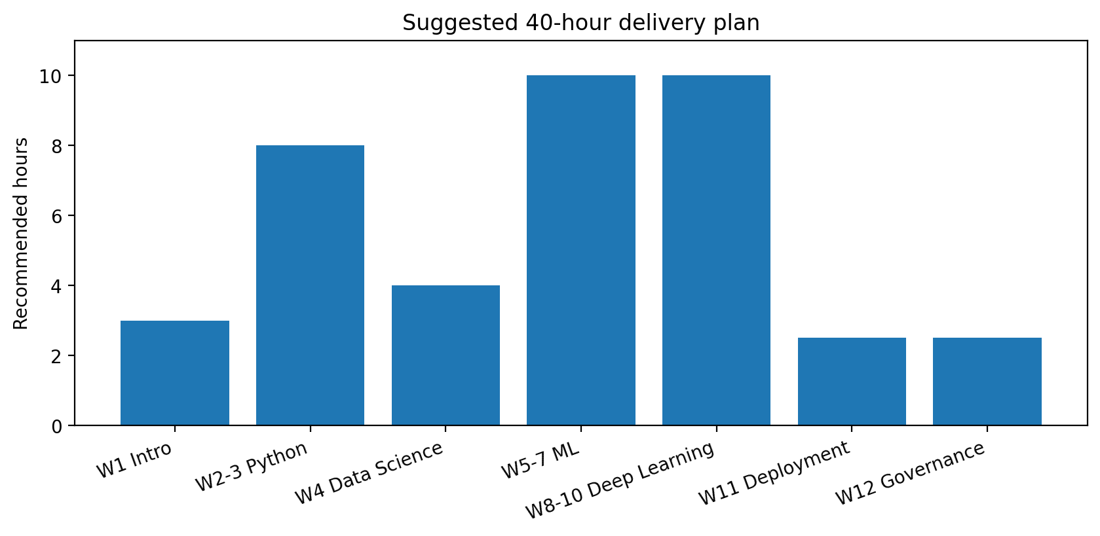
Figure 1. Suggested distribution of the 40-hour certification across the major content blocks.

1.1 International benchmark anchors
Benchmark source | Why it matters | What it contributes to this program | Where it appears
ACM/AAAI/IEEE CS2023 AI knowledge area | Curriculum quality and learning outcomes | AI concepts, intelligent systems, societal impact, ethics, evaluation | Weeks 1, 5-10, 12
SFIA AI skills framework | Industry skills mapping | Role-based competencies for analysts, engineers, and practitioners | Program outcomes and capstone
NIST AI RMF | Risk-based lifecycle governance | Govern, Map, Measure, Manage across the full AI lifecycle | Weeks 1, 11, 12
ISO/IEC 42001 and ISO/IEC 23894 | Operational governance and risk management | Organizational controls, accountability, improvement, AI-specific risk treatment | Week 12 and capstone
OECD AI Principles and UNESCO Recommendation | Responsible and human-centered AI | Human rights, fairness, transparency, accountability, sustainability | Weeks 1 and 12
Vendor practice benchmarks | Job relevance | Python, notebooks, cloud labs, deployment, computer vision, NLP exposure | Weeks 2-11

1.2 Intended audience and exit profile
- Computer science students who need a structured path from AI theory to implementation.
- Software engineers who want to add machine learning and model deployment skills.
- Data analysts who want to progress from descriptive analytics to predictive modeling.
- Cybersecurity professionals and researchers who need AI literacy for detection, automation, and governance.
By the end of the program, participants should be able to frame AI problems, prepare datasets, train and evaluate baseline machine learning and deep learning models, expose a model through an API, document limitations, and apply governance controls before deployment.

1.3 Assessment structure
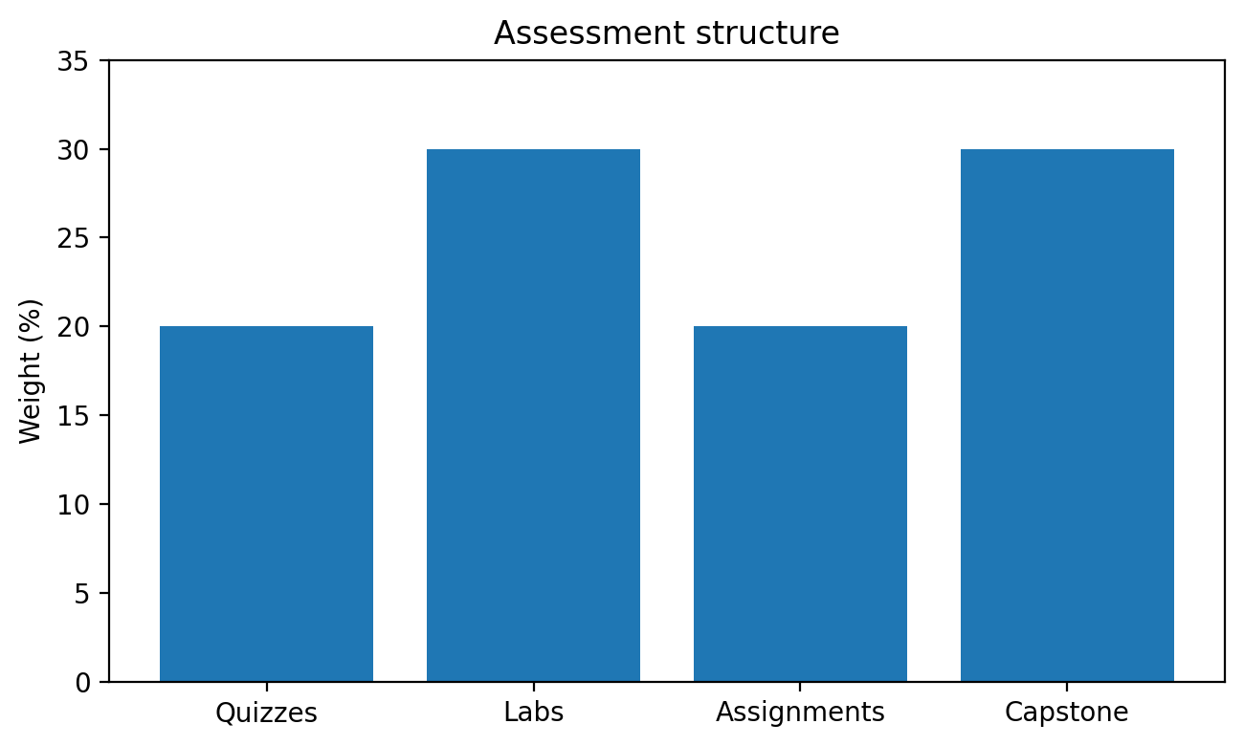
Figure 2. Assessment balance emphasizes practical execution through labs and capstone work.
Component | Weight | Internationally benchmarked rationale
Module quizzes | 20% | Checks conceptual understanding without dominating the practical skill profile.
Laboratory exercises | 30% | Builds coding fluency and reproducible engineering habits.
Assignments | 20% | Requires written analysis, interpretation, and reflection on trade-offs.
Capstone project | 30% | Aligns with portfolio-style and employer-visible evidence of competence.

2. Week 1 - Introduction to Artificial Intelligence
Learning objective: explain what AI is, distinguish intelligent agents from ordinary software, recognize major categories of AI systems, and discuss why ethics and governance must be introduced at the start rather than at the end of a project.
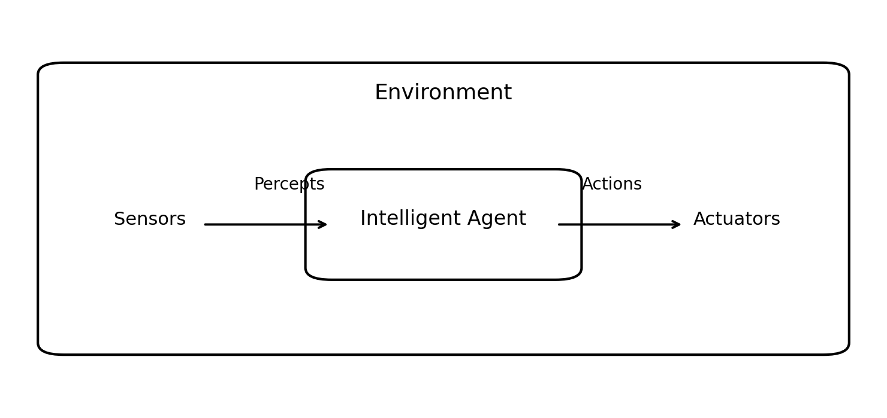
Figure 3. The classic agent view: an AI system perceives an environment and acts on it.

2.1 Core lecture notes
- AI is the discipline of designing systems that can perceive, reason, learn, and act toward goals under uncertainty.
- An intelligent agent has a performance measure, an environment, actuators, and sensors.
- Modern AI engineering combines data, models, software systems, compute infrastructure, and governance controls.
- Narrow AI dominates industry practice: fraud detection, recommendation systems, quality inspection, speech systems, chatbots, and route optimization.
- Generative AI is now important, but it should be taught as part of a broader engineering discipline that includes risk, evaluation, and deployment.

2.2 Real-world examples
Sector | AI application | Benefits | Key governance question
Banking | Card fraud detection | Reduces financial loss and response time | How are false positives handled for legitimate customers?
Manufacturing | Computer vision defect detection | Improves quality and reduces waste | What happens when lighting changes or data drift occurs?
Healthcare | Diagnostic support or triage | Faster prioritization of urgent cases | Who retains final authority over decisions?
Cybersecurity | Intrusion or anomaly detection | Earlier detection of malicious behavior | How are alerts validated and audited?

2.3 Ethics and governance note
A common teaching mistake is to treat ethics as an afterthought. International practice increasingly moves in the opposite direction. Learners should understand from the first week that performance alone is not enough; reliability, explainability, fairness, privacy, accountability, and human oversight are engineering requirements.

2.4 Lab exercise - simple rule-based AI
Scenario: build a help-desk triage assistant that routes tickets according to keywords and urgency.
rules = {
"password reset": "Identity Support",
"vpn": "Network Team",
"malware": "Security Operations",
"invoice": "Finance Helpdesk"
}

def route_ticket(text, priority="normal"):
text = text.lower()
for keyword, team in rules.items():
if keyword in text:
if priority == "high":
return f"Escalate to {team} - urgent"
return f"Route to {team}"
return "Route to General Support"

print(route_ticket("VPN access not working", priority="high"))
Teaching point: the lab introduces symbolic AI and makes it easy to discuss strengths and limits. Rule systems are interpretable and fast, but brittle when language varies.

2.5 Instructor emphasis
- Contrast automation, analytics, machine learning, and AI.
- Use a local example from the students’ context such as university admissions, telecom churn, or mobile money fraud.
- Ask learners to identify where bias might enter the design even before any model is trained.

3. Weeks 2-3 - Python Programming for AI
Learning objective: write clean Python for data and AI work, use core data structures, perform numerical operations, and manipulate tabular data using NumPy and pandas.

3.1 Why Python dominates AI education
Python combines readable syntax, an extensive scientific ecosystem, notebook workflows, and strong community support. In practice, AI engineers do not use Python alone; they use Python plus libraries and reproducible environments.
Tool | Teaching use | Industry value
Jupyter Notebook / Google Colab | Interactive teaching, explanation, experimentation | Rapid prototyping, reports, demos, education
NumPy | Arrays, vectorization, numerical computing | Core dependency for scientific Python workflows
pandas | Cleaning, joins, grouping, missing data, feature tables | Standard tabular analytics and ML preparation

3.2 Essential concepts to cover
- Variables, expressions, and control flow.
- Functions, parameters, return values, and docstrings.
- Lists, dictionaries, tuples, and sets.
- Iteration patterns, comprehensions, and error handling.
- File I/O and CSV basics.
- Vectorized computation with NumPy arrays instead of slow Python loops when possible.
- DataFrames, filtering, grouping, merging, and missing-value handling with pandas.

3.3 Code example - preprocessing a student dataset
import pandas as pd

df = pd.read_csv("students.csv")

df["attendance_rate"] = df["classes_attended"] / df["classes_total"]
df["final_score"] = (
0.2 * df["quiz_avg"] +
0.3 * df["lab_avg"] +
0.2 * df["assignment_avg"] +
0.3 * df["exam_score"]
)

df["risk_flag"] = (df["attendance_rate"] < 0.70) | (df["final_score"] < 60)
summary = df.groupby("risk_flag")[["attendance_rate", "final_score"]].mean()
print(summary)

3.4 Real-world examples
- Fintech: cleaning transaction logs before fraud modeling.
- Retail: joining customer, product, and order tables to compute demand features.
- Security operations: parsing alerts, timestamps, and host logs before anomaly detection.
- Public health: aggregating case reports by region and date for early trend analysis.

3.5 Mini lab checklist
- Load data from CSV into a DataFrame.
- Inspect shape, columns, and data types.
- Handle missing values and duplicates.
- Create at least two engineered columns.
- Export the cleaned result for downstream modeling.

4. Week 4 - Data Science Foundations
Learning objective: clean messy data, build basic visualizations, and engineer features that improve model usefulness.
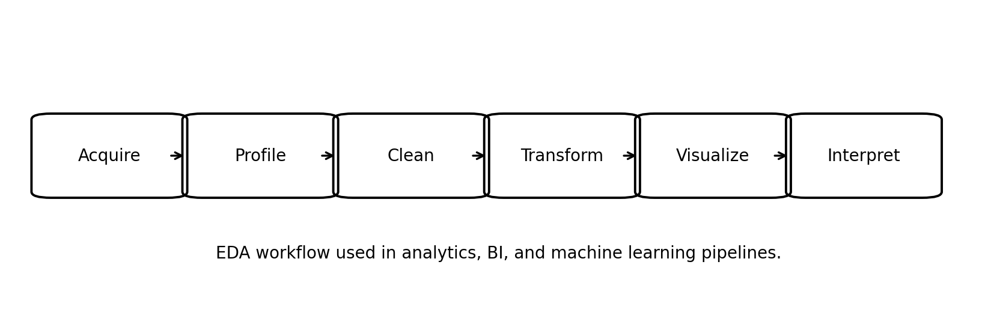
Figure 4. Exploratory data analysis turns raw records into usable analytical evidence.

4.1 Lecture notes
- Dirty data reduces model trust faster than weak algorithms do.
- Data cleaning includes type fixing, missing-value treatment, duplicate removal, outlier inspection, and consistency checks.
- Feature engineering transforms domain knowledge into machine-usable signals.
- Visualization is not decoration; it is a diagnostic tool for skew, leakage, imbalance, drift, and relationships.

4.2 Typical cleaning decisions
Issue | Example | Possible treatment | Risk if ignored
Missing values | Income field blank | Impute, flag, or remove | Biased or invalid training input
Duplicates | Same transaction repeated | Deduplicate by key and timestamp | Inflated counts and distorted labels
Outliers | Impossible age or amount | Validate or cap after investigation | Skewed models and misleading charts
Data leakage | Post-outcome variable used as predictor | Drop leakage feature before training | Artificially high accuracy

4.3 Visualization code example
import matplotlib.pyplot as plt

monthly = df.groupby("month")["fraud_amount"].sum()

plt.figure(figsize=(8, 4))
plt.plot(monthly.index, monthly.values, marker="o")
plt.title("Monthly Fraud Amount")
plt.xlabel("Month")
plt.ylabel("Amount")
plt.tight_layout()
plt.show()
Instructor note: if seaborn is available, use it to introduce higher-level statistical visualizations such as boxplots and pairplots, but make sure learners still understand the underlying data logic.

4.4 Real-world examples
- Telecommunications churn data: create tenure bands, monthly usage ratios, and complaint frequency features.
- Healthcare triage: derive waiting-time bands, prior-visit counts, and risk categories from raw records.
- Manufacturing quality control: convert machine logs into rolling averages and recent-failure indicators.

5. Weeks 5-7 - Machine Learning
Learning objective: understand supervised and unsupervised learning, train baseline models, evaluate results correctly, and select models appropriate to the business problem.
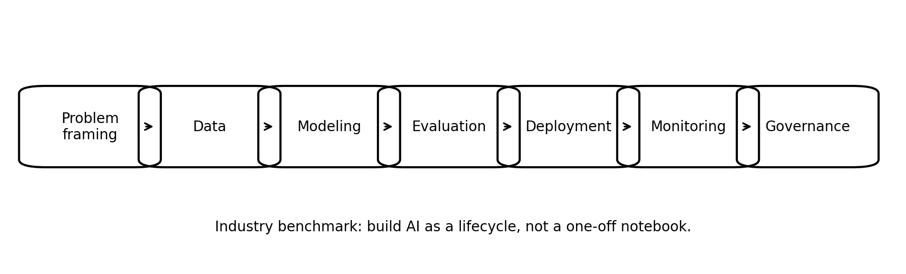
Figure 5. The machine learning workflow sits inside a broader engineering lifecycle.

5.1 Core topics
- Supervised learning: classification and regression.
- Train-validation-test splitting and cross-validation.
- Feature scaling and preprocessing pipelines.
- Classification algorithms such as logistic regression, decision trees, random forests, and support vector machines.
- Regression models for continuous outcomes.
- Clustering techniques such as k-means for segmentation and exploratory grouping.
- Evaluation using accuracy, precision, recall, F1, ROC-AUC, MAE, RMSE, and confusion matrices.

5.2 When to use what
Problem type | Typical question | Example algorithm | Common metric | Business example
Binary classification | Will this email be spam? | Logistic regression / random forest | Precision, recall, F1 | Email filtering
Multiclass classification | Which defect class is present? | Tree ensemble / SVM | Accuracy, F1 | Factory inspection
Regression | What will demand be next week? | Linear regression / gradient boosting | MAE, RMSE | Retail forecasting
Clustering | Which customer segments exist? | k-means | Silhouette score | Marketing segmentation

5.3 Lab exercise - spam email classifier
from sklearn.model_selection import train_test_split
from sklearn.feature_extraction.text import TfidfVectorizer
from sklearn.pipeline import Pipeline
from sklearn.linear_model import LogisticRegression
from sklearn.metrics import classification_report

X_train, X_test, y_train, y_test = train_test_split(
emails["text"], emails["label"], test_size=0.2, random_state=42, stratify=emails["label"]
)

model = Pipeline([
("tfidf", TfidfVectorizer(stop_words="english")),
("clf", LogisticRegression(max_iter=1000))
])

model.fit(X_train, y_train)
pred = model.predict(X_test)
print(classification_report(y_test, pred))

5.4 Real-world interpretation guidance
- High accuracy can still be misleading on imbalanced datasets. A fraud model that predicts 'not fraud' for everyone may look accurate but be useless.
- Precision matters when false alarms are costly. Recall matters when missed cases are dangerous.
- Always inspect class balance, leakage risk, and whether the training data still represents current operations.

5.5 Instructor extension
Ask students to compare a simple baseline model with a more complex one. This teaches a major engineering lesson: the best model is often the simplest model that meets the operational requirement.

6. Weeks 8-10 - Deep Learning
Learning objective: understand neural networks, backpropagation, and convolutional neural networks, then build an image classifier using TensorFlow or PyTorch.
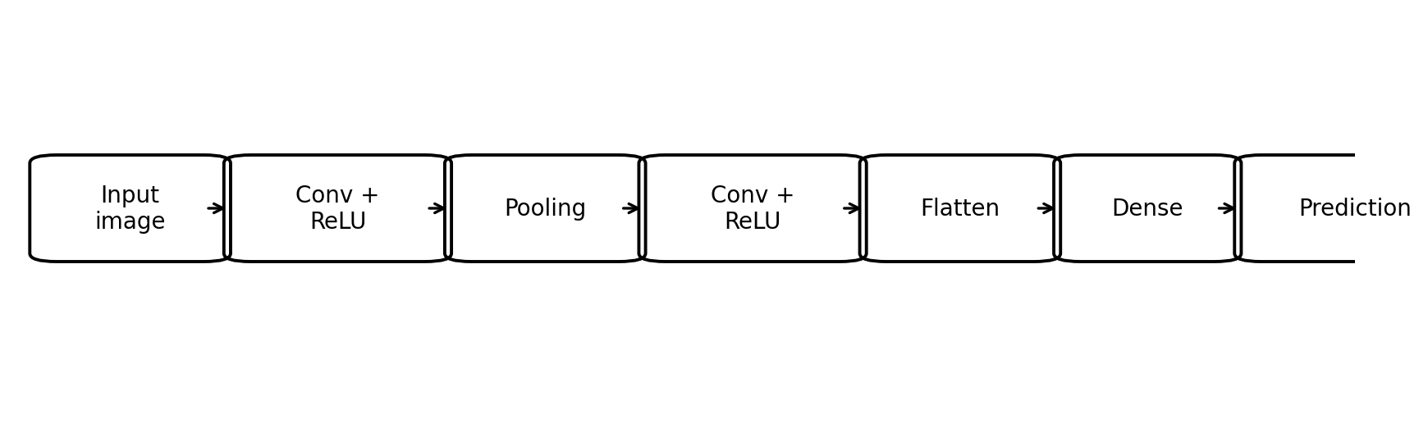
Figure 6. A simplified convolutional neural network pipeline for image classification.

6.1 Lecture notes
- A neural network learns layered representations by adjusting weights to reduce a loss function.
- Backpropagation computes gradients so optimization methods such as stochastic gradient descent or Adam can update the weights.
- Deep learning is powerful for images, speech, and complex patterns, but it usually requires more data, compute, and monitoring than classical ML.
- Overfitting, class imbalance, poor labeling, and domain shift remain major practical risks.

6.2 TensorFlow example
import tensorflow as tf
from tensorflow.keras import layers, models

model = models.Sequential([
layers.Input(shape=(28, 28, 1)),
layers.Conv2D(32, (3, 3), activation="relu"),
layers.MaxPooling2D((2, 2)),
layers.Conv2D(64, (3, 3), activation="relu"),
layers.MaxPooling2D((2, 2)),
layers.Flatten(),
layers.Dense(64, activation="relu"),
layers.Dense(10, activation="softmax")
])

model.compile(optimizer="adam",
loss="sparse_categorical_crossentropy",
metrics=["accuracy"])

6.3 PyTorch example
import torch
import torch.nn as nn

class SimpleCNN(nn.Module):
def __init__(self):
super().__init__()
self.features = nn.Sequential(
nn.Conv2d(1, 32, 3), nn.ReLU(), nn.MaxPool2d(2),
nn.Conv2d(32, 64, 3), nn.ReLU(), nn.MaxPool2d(2)
)
self.classifier = nn.Sequential(
nn.Flatten(),
nn.Linear(64 * 5 * 5, 64),
nn.ReLU(),
nn.Linear(64, 10)
)

def forward(self, x):
return self.classifier(self.features(x))

6.4 Real-world examples
- Medical imaging: classify chest scans or retinal images, always with human review and strict validation.
- Agriculture: identify crop disease from leaf images.
- Industrial automation: detect defects on conveyor-belt imagery.
- Security: classify malicious files, faces, or objects only where lawful and ethically justified.

6.5 Instructor caution
Do not let learners conclude that deep learning is automatically better than classical ML. In many tabular business problems, gradient boosting or tree ensembles may outperform deep networks with lower operational cost.

7. Week 11 - AI System Deployment
Learning objective: package a trained model, expose it through an API, and understand the basics of containers, cloud runtime, and monitoring.
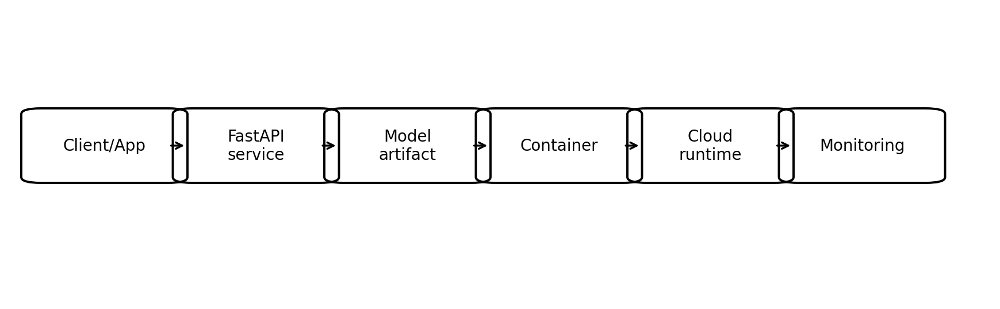
Figure 7. A minimal deployment pattern for a prediction service.

7.1 Deployment concepts
- Model deployment is the process of making a trained model available to users or systems in production.
- An API layer makes the model accessible to other applications in a standard and testable way.
- Containers improve replicability and reduce the gap between local development and production deployment.
- Monitoring must track uptime, latency, input quality, output quality, drift, and security events.

7.2 FastAPI web service example
from fastapi import FastAPI
import joblib
import numpy as np

app = FastAPI(title="Loan Risk API")
model = joblib.load("loan_model.joblib")

@app.post("/predict")
def predict(features: list[float]):
x = np.array(features).reshape(1, -1)
pred = model.predict(x)[0]
prob = float(model.predict_proba(x)[0][1])
return {"prediction": int(pred), "risk_probability": prob}

7.3 Minimal Dockerfile
FROM python:3.12-slim
WORKDIR /app
COPY requirements.txt .
RUN pip install -r requirements.txt
COPY . .
CMD ["uvicorn", "main:app", "--host", "0.0.0.0", "--port", "8000"]

7.4 Real-world examples
- A bank deploys a fraud scoring API called by its transaction-processing system.
- A hospital deploys a triage-support model behind an internal dashboard rather than exposing it directly to patients.
- A retailer deploys demand forecasts to inventory planning tools and refreshes them daily.

7.5 Production checklist
- Version the data, model, code, and API contract.
- Define rollback procedures before go-live.
- Protect endpoints with authentication and rate limits.
- Log predictions and errors in a privacy-aware way.
- Establish thresholds for retraining, drift investigation, and human escalation.

8. Week 12 - AI Governance and Ethics
Learning objective: explain explainable AI, AI risk management, algorithmic bias, and major governance frameworks that influence responsible AI practice.
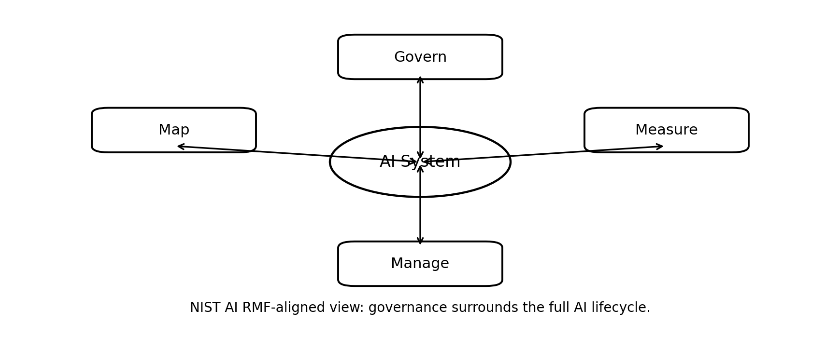
Figure 8. Governance is a continuous control loop around the AI system lifecycle.

8.1 Essential themes
- Explainability: can stakeholders understand what the model uses and why a result was produced?
- Bias and fairness: do outcomes systematically disadvantage groups because of data, labels, proxies, or design choices?
- Risk management: what harms, failures, misuse, and unintended consequences must be identified and controlled?
- Accountability: who approves, audits, documents, and owns the system at each stage?
- Human oversight: where must a person review, override, or halt the system?

8.2 Governance table
Control area | Practical question | Example evidence | Responsible role
Explainability | Can we explain important factors behind predictions? | Feature importance, SHAP summary, model card | ML engineer / analyst
Bias testing | Do error rates differ across groups? | Fairness report and subgroup evaluation | Data scientist / reviewer
Risk management | What can fail and what is the fallback? | Risk register and incident plan | Product owner / governance lead
Monitoring | Are drift or misuse signals rising? | Monitoring dashboard and alert thresholds | MLOps / operations

8.3 Bias example for class discussion
Suppose a hiring model is trained on past employee records from a department that historically hired mostly one demographic group. Even if the model never sees a protected attribute directly, it may still learn biased proxies such as school, postcode, or career gaps. The lesson is that bias testing must examine both data and outcomes.

8.4 Governance mini-lab
- Pick one model built earlier in the course.
- Document intended use, users, and known limitations.
- List at least five failure modes or misuse cases.
- Propose human-review checkpoints and logging requirements.
- Write a one-page model card or deployment approval note.

For advanced cohorts, add a short discussion of generative AI security, including prompt injection, insecure output handling, data poisoning, and model denial-of-service, especially for students working on AI assistants or agentic systems.

9. Student workshops, expert panels, and capstone integration
The program becomes significantly stronger when lectures are reinforced with workshops, visiting-practitioner panels, and a capstone that integrates technical and governance thinking.

9.1 Suggested workshops
Workshop | Format | Output | Benchmark value
Notebook clinic | Live debugging session | Fixed data-cleaning notebook | Builds practical coding confidence
Model critique studio | Group review of trained models | Evaluation memo and improvement plan | Improves analytical judgment
Deployment drill | Containerize and expose a model | Working API demo | Bridges model building and production
Responsible AI roundtable | Case-based discussion | Risk register and model card | Strengthens governance literacy

9.2 Expert panel prompts
- How do you decide whether an AI problem is worth solving with ML at all?
- What is the most common cause of model failure after deployment?
- How does your organization handle explainability, documentation, and accountability?
- What entry-level AI engineering skills make a candidate immediately useful?

9.3 Example capstone projects
Project | Data | Modeling goal | Deployment idea | Governance note
AI fraud detection model | Transaction records | Binary classification | Internal scoring API | False-positive review workflow
AI cybersecurity intrusion detection system | Network or host telemetry | Anomaly or attack classification | SOC dashboard integration | Audit trail and analyst approval
AI healthcare prediction model | Clinical or operational data | Risk prediction | Internal hospital decision support | Human-in-the-loop review and privacy control

10. Software, tools, and curated video resources
Videos should reinforce, not replace, the lecture notes. The best practice is to assign short official or highly reputable videos before labs so class time can focus on explanation and practice.

10.1 Required software stack
Tool | Primary use | Required? | Suggested note
Python | Language for all labs | Yes | Use current stable 3.x release
Jupyter Notebook / JupyterLab | Interactive notebooks | Yes | Best for teaching and submission
Google Colab | Cloud notebook option | Recommended | Useful for zero-setup labs
scikit-learn | Machine learning | Yes | Classical ML benchmark library
TensorFlow | Deep learning | Yes | Good for high-level and production-ready examples
PyTorch | Deep learning | Yes | Popular in research and increasingly in production

10.2 Suggested videos and labs by section
Week 1: Google Machine Learning Crash Course - introductory modules
Weeks 2-3: Project Jupyter - Try Jupyter and Jupyter Notebook orientation
Weeks 2-3: NumPy absolute basics for beginners
Weeks 2-3: 10 minutes to pandas
Week 4: Matplotlib quick start guide
Weeks 5-7: scikit-learn getting started
Weeks 8-10: TensorFlow 2 quickstart for beginners
Weeks 8-10: PyTorch Learn the Basics
Week 11: FastAPI first steps
Week 11: Docker getting started workshop
Week 12: NIST AI RMF Playbook

10.3 Recommended delivery pattern
- Assign one short pre-class video or reading.
- Use the lecture to explain concepts and address misconceptions.
- Use the lab to build, debug, and interpret outputs.
- Use a reflection note to connect technical decisions with governance and business impact.

11. Certificate layout guidance
The certificate should look formal, readable, and verifiable. Avoid clutter. A clean academic-professional style is usually more credible than a decorative one.
Element | Recommended content
Header | AMK Research Lab logo and tagline: Science • Intelligence • Innovation
Title | Professional Certificate in Artificial Intelligence
Award statement | Awarded to [Student Name] for successfully completing Artificial Intelligence Engineering Fundamentals
Verification fields | Completion date, certificate ID, course hours
Signatures | Director, AMK Research Lab; Program Instructor
Footer | AMK Research Lab - AI • Cybersecurity • Innovation
Good practice: issue each certificate with a unique identifier and maintain a verification register. This improves credibility and reduces fraud risk.

12. Selected benchmark references
The resources below were used as benchmark anchors for the curriculum design, tool selection, and governance framing.
NIST AI Risk Management Framework and AI RMF Playbook
NIST AI RMF resource center
ISO/IEC 42001:2023 - AI management systems
ISO/IEC 23894:2023 - AI guidance on risk management
ISO AI standards overview
OECD AI Principles
OECD Recommendation of the Council on AI
UNESCO Recommendation on the Ethics of Artificial Intelligence
ACM / AAAI / IEEE-CS CS2023 curricular guidelines
ACM AI knowledge area draft
SFIA AI skills framework
Microsoft AI-102 study guide
Google Machine Learning Crash Course
Project Jupyter
NumPy documentation
pandas documentation
scikit-learn user guide
Matplotlib documentation
TensorFlow tutorials
PyTorch tutorials
FastAPI deployment documentation
OpenAPI specification
Docker getting started
European Commission AI Act overview
OWASP Top 10 for LLM applications

13. Instructor closing note
These notes are intentionally practice-oriented. An internationally competitive AI engineering program should not stop at algorithm description. It should teach students how to reason about data quality, verify performance, expose models safely, communicate limitations, and align deployment choices with legal, ethical, and organizational constraints.

